Scholarship Monitoring and Academic Compliance System
Systems Analysis and Design – Comprehensive Laboratory Examination, Section B – Part I: Analysis and Design
Name: Romy John L. Astronomo
Student ID: M-006668 Program and year: BSIT 3-B Date: 10-21-2026

A1. Investigation and Planning

Problem statement
The Scholarship Office administers Excellence Scholar and Access Scholar grants using spreadsheets, email attachments and paper grade records. Duplicate semester entries, unverified grades, missed deadlines and inconsistent decisions delay renewal, and scholars cannot see whether their submission was received, verified or returned for correction. A browser-based system is needed so scholars can submit semester academic summaries and staff can verify evidence, evaluate policy compliance and record renewal decisions consistently.

Problem, cause and effect
No. | Problem | Cause | Effect
1 | Duplicate semester entries | Records are spread across spreadsheets and emails with no unique check | Conflicting records; staff waste time reconciling them
2 | Unverified grades are used | No required verification step before a decision | Wrong renewal decisions based on unchecked data
3 | Deadlines are missed or not enforced | Submission time is not recorded consistently | Late submissions are accepted or rejected unfairly
4 | Scholars cannot see their status | No shared place to track received, verified or returned | Repeated follow-up emails; delayed renewal

Scope and exclusions
In scope: two roles (Scholar, Scholarship Staff); sign-in with role-based access; scholar registration and program assignment; semester grade submission with validation and duplicate prevention; evidence verification (Verified or Returned with reason) and correction; compliance evaluation using program policies; renewal decision (Approved or Held); dashboard, search and filters; history log of verification, evaluation and renewal changes.
Exclusions: live Registrar API, SMS gateway, machine learning, payment module, full appeal workflow, policy exceptions, and any change to official grades or release of scholarship payments. The Registrar remains the source of official grades.

Development tasks
No. | Task | Output
T1 | Create database schema, keys, policies and access rules | schema.sql
T2 | Implement scholar assignment and grade submission with validation | Submission screen and function
T3 | Implement verification, correction, compliance and renewal | Staff screens and functions
T4 | Implement dashboard, search, history, then test TC01 to TC10 | Dashboard and test results

Risks and responses
No. | Risk | Response
R1 | Network or hosting failure during the exam | Provide a runnable local copy with run instructions and the error message
R2 | Policy logic errors at boundaries (GWA 2.00, exact deadline) | Seed boundary records B01 to B06 and run TC01 to TC05 before submitting

A2. Stakeholders and Elicitation

Stakeholders
Stakeholder | Interest | Actual actor of the system?
Scholar | Submits grades, tracks status | Yes (primary actor)
Scholarship Staff | Verifies evidence, evaluates, decides renewal | Yes (primary actor)
Registrar | Source of official grades | No (external; not a user of this system)
Scholarship Office Head | Needs consistent decisions and reports | No (reads results through staff)

Elicitation questions (open-ended)
- Verification: How do you currently check that a grade document is genuine, and what makes you return one to a scholar?
- Verification: What should a scholar see when their evidence is returned, and how do they correct it?
- Deadlines: How is the submission deadline set for each program, and what happens to a scholar who submits after it?
- Policy exceptions: Which situations lead you to hold renewal rather than reject, and who decides?
- Access: Who may see a scholar's grades, and what should a scholar never be able to see or change?
- Reports: What counts and lists do you need each semester to decide renewals quickly?

A3. Requirements and Rules

Functional requirements
ID | Requirement (testable)
FR01 | The system shall require sign-in; unauthenticated users see no data.
FR02 | A scholar shall be able to view only their own submissions; staff shall be able to view all submissions (role access).
FR03 | Staff shall register a scholar (student ID, name) and assign exactly one of two persisted program policies.
FR04 | A scholar shall submit an academic year, semester, GWA, enrolled units, failed, incomplete and dropped counts, and a grade-document reference; the system records the timestamp.
FR05 | The system shall reject GWA outside 1.00 to 5.00, negative or non-integer counts, and a missing evidence reference, with a clear message.
FR06 | The system shall reject a second submission for the same scholar, academic year and semester (duplicate prevention).
FR07 | Staff shall mark evidence Verified or Returned; Returned requires a reason; a corrected resubmission returns to Pending verification.
FR08 | The system shall evaluate only Verified submissions, reading thresholds from the assigned program record, and display each check and deficiency reason.
FR09 | Staff shall record Approved or Held with a note; Approved is allowed only when the evaluation is Compliant.
FR10 | The system shall log every verification, evaluation, renewal change and submission with actor, action, detail and timestamp.

Non-functional requirements (measurable)
ID | Requirement
NFR01 | Security: 100% of write actions on submissions go through role-checked backend functions; direct table writes are denied.
NFR02 | Performance: dashboard and search results for 6 seeded scholars display within 3 seconds on a normal connection.
NFR03 | Persistence: after a browser refresh, 100% of saved submissions, decisions and history entries remain.
NFR04 | Usability: a scholar completes a grade submission in no more than 8 input fields and receives a result message within 3 seconds.

Business rules
ID | Rule
BR01 | Role access: a scholar can read only their own records; only staff can verify, evaluate and decide renewal.
BR02 | Verification: only Verified evidence may be evaluated; missing or unverified evidence blocks final evaluation.
BR03 | Policy selection: thresholds come from the scholar's assigned program (Excellence: GWA ≤ 2.00, units ≥ 18, failed 0, incomplete 0, dropped 0; Access: GWA ≤ 2.50, units ≥ 15, failed 0, incomplete 0, dropped ≤ 1).
BR04 | Duplicate prevention: one submission per scholar, academic year and semester.
BR05 | Deadline: 2026-11-06 17:00 Asia/Manila; a submission at the exact deadline is on time, after it is late (late produces With Deficiency).
BR06 | Renewal authority: staff decide renewal; a record With Deficiency cannot be approved, only held; an evaluation flag does not disqualify automatically; submission status, compliance and award status are separate.

A4. UML Use Case Modeling
Actors: Scholar and Scholarship Staff (mandatory roles). Authentication is a precondition of every use case, not an include relationship. The Registrar is external and is not modeled as an actor.
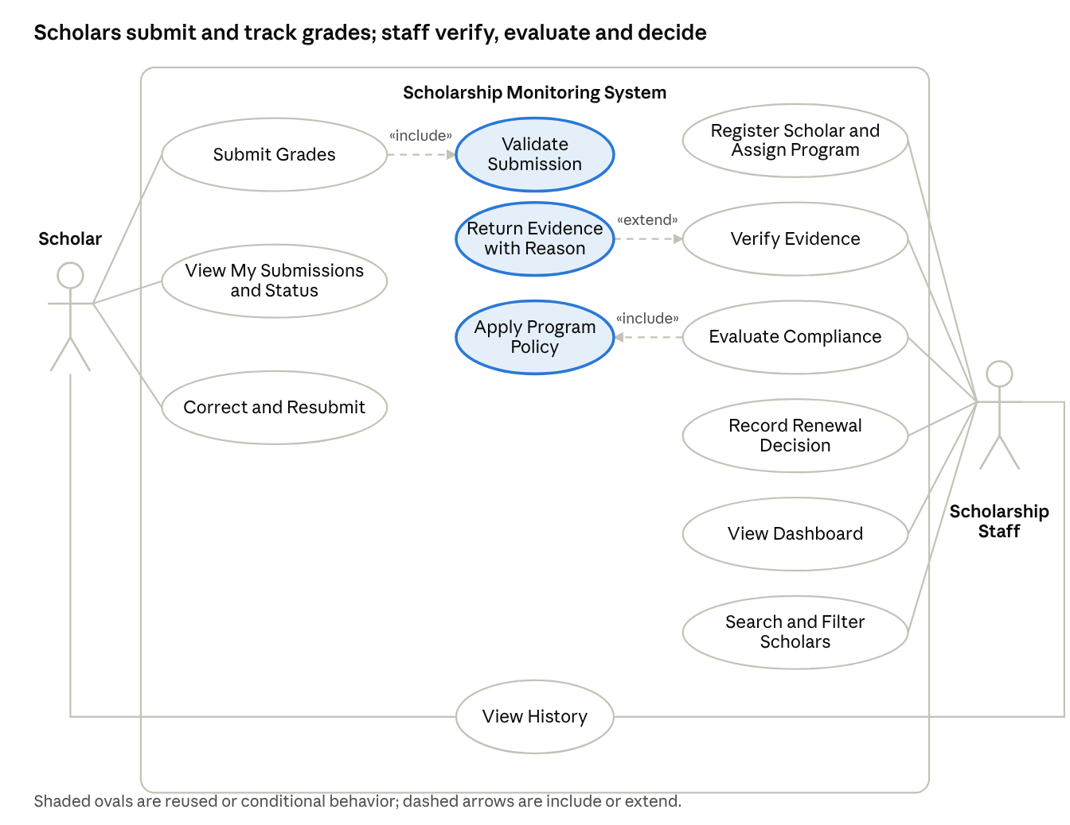
use case diagram · 2 actors, 10 goals, 2 includes, 1 extend
Figure A4-1. The Scholar and Scholarship Staff roles with the system boundary; the two include relationships and one extend relationship are explained below.

User goals
ID | Use case | Actor
UC01 | Submit Grades | Scholar
UC02 | View My Submissions and Status | Scholar
UC03 | Correct and Resubmit | Scholar
UC04 | Register Scholar and Assign Program | Staff
UC05 | Verify Evidence | Staff
UC06 | Evaluate Compliance | Staff
UC07 | Record Renewal Decision | Staff
UC08 | View Dashboard | Staff
UC09 | Search and Filter Scholars | Staff
UC10 | View History | Scholar, Staff

Relationships and justification
- UC01 Submit Grades «include» Validate Submission: validation (GWA range, counts, duplicate check) is mandatory every time grades are submitted, so it is reused behavior.
- UC06 Evaluate Compliance «include» Apply Program Policy: every evaluation must read the assigned program thresholds, so applying the policy is mandatory reused behavior.
- Return Evidence with Reason «extend» UC05 Verify Evidence: returning evidence happens only when the evidence is found incomplete or wrong (extension point: evidence not acceptable), so it is conditional added behavior.

A5. Detailed Use Cases and Data Design

UC01 Submit Grades
Item | Description
Actor | Scholar
Trigger | The scholar chooses to submit a semester academic summary.
Preconditions | Scholar is signed in, is linked to a scholar record and has an assigned program.
Linked IDs | FR02, FR04, FR05, FR06, FR10; BR01, BR04, BR05
Main flow
- The scholar selects the academic year and semester.
- The scholar enters GWA, enrolled units, failed, incomplete and dropped counts.
- The scholar enters the grade-document reference.
- The scholar submits the form.
- The system validates the input (include: Validate Submission).
- The system saves the submission with the current timestamp and status Pending verification.
- The system writes a history entry and shows a confirmation.
Alternative flows
- 5a. A required field is empty: the system shows which field is missing and keeps the form.
Exception flows
- 5b. GWA is outside 1.00 to 5.00 or a count is negative: the system rejects the input with a clear message.
- 5c. A submission already exists for the same year and semester: the system rejects it and shows a duplicate message.
- 1a. The account is not linked to a scholar record: the system shows a message to contact staff.
Postcondition: A Pending submission exists for the scholar, term and timestamp, and the event is in the history.

UC06 Evaluate Compliance
Item | Description
Actor | Scholarship Staff
Trigger | Staff chooses to evaluate a submission.
Preconditions | Staff is signed in; the submission exists; its evidence is Verified.
Linked IDs | FR08, FR10; BR02, BR03, BR05, BR06
Main flow
- Staff selects a submission and chooses Evaluate.
- The system checks that evidence is Verified.
- The system reads the thresholds of the scholar's assigned program (include: Apply Program Policy).
- The system checks GWA, enrolled units, failed, incomplete and dropped counts, and the submission time against the deadline.
- The system sets the result Compliant when all checks pass.
- The system saves the result and reasons, and writes a history entry.
- The system displays the result.
Alternative flows
- 5a. One or more checks fail: the system sets With Deficiency and lists each specific reason (for example GWA above limit, units below minimum, late submission).
Exception flows
- 2a. Evidence is Pending or Returned: the system blocks evaluation and shows that verification is required first.
- 3a. The scholar has no assigned program: the system blocks evaluation and shows a message.
Postcondition: The submission has a compliance result (Compliant or With Deficiency) with reasons, and the evaluation is in the history. Renewal is not decided automatically.

Entity relationship diagram
Core entities: PROGRAMS, SCHOLARS, PROFILES, SUBMISSIONS, HISTORY. Keys and cardinalities are shown in the diagram below and in this table.
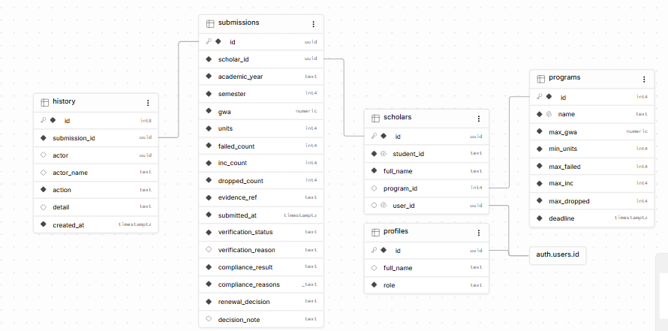
entity relationship diagram · 5 entities with keys and cardinalities
Figure A5-1. One program has many scholars, one scholar has many submissions, and each submission has many history entries.
Entity | Primary key | Foreign keys | Notes
programs | id | none | Policy thresholds and deadline
profiles | id (= auth user id) | auth.users | Role: scholar or staff
scholars | id | program_id → programs; user_id → auth user | student_id unique
submissions | id | scholar_id → scholars | Unique (scholar_id, academic_year, semester)
history | id | submission_id → submissions | Actor, action, detail, timestamp
Cardinalities: one program has many scholars; one scholar has many submissions (one per term); one submission has many history entries; one auth user has one profile and at most one scholar record.

A6. Traceability
FR | Actor | Use case | Business rule | Implemented screen or function | Test and expected result
FR06 | Scholar | UC01 Submit Grades | BR04 | Submit form; submit_grades function with unique key | TC07: duplicate semester, GWA 0.50 and negative count are rejected with a clear message
FR08 | Staff | UC06 Evaluate Compliance | BR02, BR03, BR05 | Evaluate button; evaluate_submission function | TC01 B01 Compliant; TC02 B02 With Deficiency (GWA); TC04 B04 units and incomplete; TC05 B05 failed and late
FR09 | Staff | UC07 Record Renewal Decision | BR06 | Approve and Hold buttons; decide_renewal function | TC10: compliant record approved; deficient record cannot be approved, only held; scholar cannot change it
FR02 | Scholar, Staff | UC02 View My Submissions and Status | BR01 | Row Level Security on submissions and scholars | TC08: scholar cannot read another scholar's record or verify; access denied by the backend
Planned requirement not implemented: in-app editing of program policy thresholds. The thresholds are stored in the programs table and read by the evaluation function, but they are changed through the database table editor, not through a screen. This was planned but is outside the required mandatory path.

